# Requirements – Student #5

Please, fill in the following form, make sure that you have ticked the requirements that you consider fulfilled, save this document, **and attach it in its original format (.docx)** to every deliverable. Regarding your ID, please keep only four random digits and mask the others using an asterisk. **Please, note that this document must be edited with the desktop version of Word since the web version does not properly support forms.** Attaching this document entails that you are the authors of the work delivered, you have not cheated in any way, and you have read and understood the information delivered regarding the subject, with a special emphasis on the methodological guidelines and how your work is going to be graded. Make sure that your project works well with the latest version of the development framework.

|  |
| --- |
| **Group:** C2.032 |
| **Repository:** https://github.com/Javiergutpas/Acme-ANS-C2 |
| **Student #2**  **ID Number:** 7****686N  **UVUS:**  nundelesc  **Name:**  Del Pino Escalante, Nuno José  **Roles:**  Developer, Tester, Analyst, Operator |
| **Date:** Sevilla Febrero 20, 2025 |

# MANDATORY Deliverable D01: introduction

## Information requirements

Intentionally blank.

## Functional requirements

1. Modify the anonymous menu so that it shows an option that takes the browser to the home page of your favourite web site. The title must read as follows: “〈id-number〉: 〈surname〉, 〈name〉”, where “〈id-number〉” denotes your DNI, NIE, or passport number, “〈surname〉” denotes your surname/s, and “〈name〉” denotes your name/s.

X

## Non-functional requirements

Intentionally blank.

## Testing requirements

Intentionally blank.

## Managerial requirements

1. Provide a link to your planning dashboard in GitHub to review the tasks, their current status, and your schedule.

X

# MANDATORY Deliverable D02: data models

## Information requirements

1. The **technicians** care of aircraft maintenance by conducting regular inspections, performing repairs, and carrying out other maintenance tasks. The system must store the following data about them: a **license number** (unique, pattern "^[A-Z]{2-3}\d{6}$"), a **phone number** (pattern "^\+?\d{6,15}$"), their **specialisation** (up to 50 characters), whether they have passed their **annual health test** or not, and their **years of experience**. Optionally, the system may store their **certifications** (up to 255 characters).

X

1. **Maintenance records** are comprehensive records of activities performed on a given **aircraft** throughout its operational life. The system must store the following data about them: the **moment** when a maintenance takes place, its **status** ("PENDING", "IN PROGRESS", "COMPLETED"), the next **inspection due date**, an **estimated cost**, and some optional **notes** (up to 255 characters).

X

1. **Maintenance records** rely on **tasks**. A task is a specific predefined operational duty carried out by a **technician** on **aircrafts**. The system must store the following data about tasks: their **type** ("MAINTENANCE", "INSPECTION", "REPAIR", "SYSTEM CHECK"), a **description** (limited to 255 characters), a **priority** (ranging from 0 to 10), and an **estimated duration** (in hours).

X

## Functional requirements

Intentionally blank.

## Non-functional requirements

Intentionally blank.

## Testing requirements

1. Produce assorted sample data to test your application informally. The data must include two **technician** accounts with credentials “**technician1**/ **technician1**” and “**technician2**/ **technician2**”. Create an additional technician account with credentials “**technician3/ technician3”** that represents a technician with no data, but his or her profile.

X

## Managerial requirements

1. Provide a link to your planning dashboard in GitHub to review the tasks, their current status, and your schedule.

X

# MANDATORY Deliverable D03: implementing features

## Information requirements

Intentionally blank.

## Functional requirements

1. Operations by **technicians** on **maintenance records**:

* List their maintenance records.
* Show the details of the maintenance records, including the tasks involved.
* Create, update, and publish maintenance records. Please, note that to publish a maintenance record, it cannot have any unpublished tasks and should have at least one published task.

X No se deberían de usar los ids de la BD en los desplegables, esa información es transparente para el usuario final y no tiene ningún significado:

Para solucionar dicha deficiencia se cambió lo que el unbind enviaba al formulario, lo cual antes eran los ids, per tras buscar una mejor solución se decidió poner la descripción.

Esto mismo pasaba en el formulario de la creación de los maintenance record, pero con los aviones, y se decidió cambiar la selección al “registrationNumber” del avión ya que es una propiedad más significatiba y transparente para el usuario final que los id de la base de datos.

1. Operations by **technicians** on **tasks**:

* List their tasks and show their details.
* Create, update, delete, and publish tasks. Note that published tasks cannot be updated or deleted.

X Un technician puede publicar las tasks de otro technician mediante POST hacking. Lo muestro a continuación. technician3/technician3 tiene dos tareas, una publicada y otra sin publicar. La segunda tarea que no tiene publicada tiene el id = 679 (como se puede apreciar en la segunda imagen):

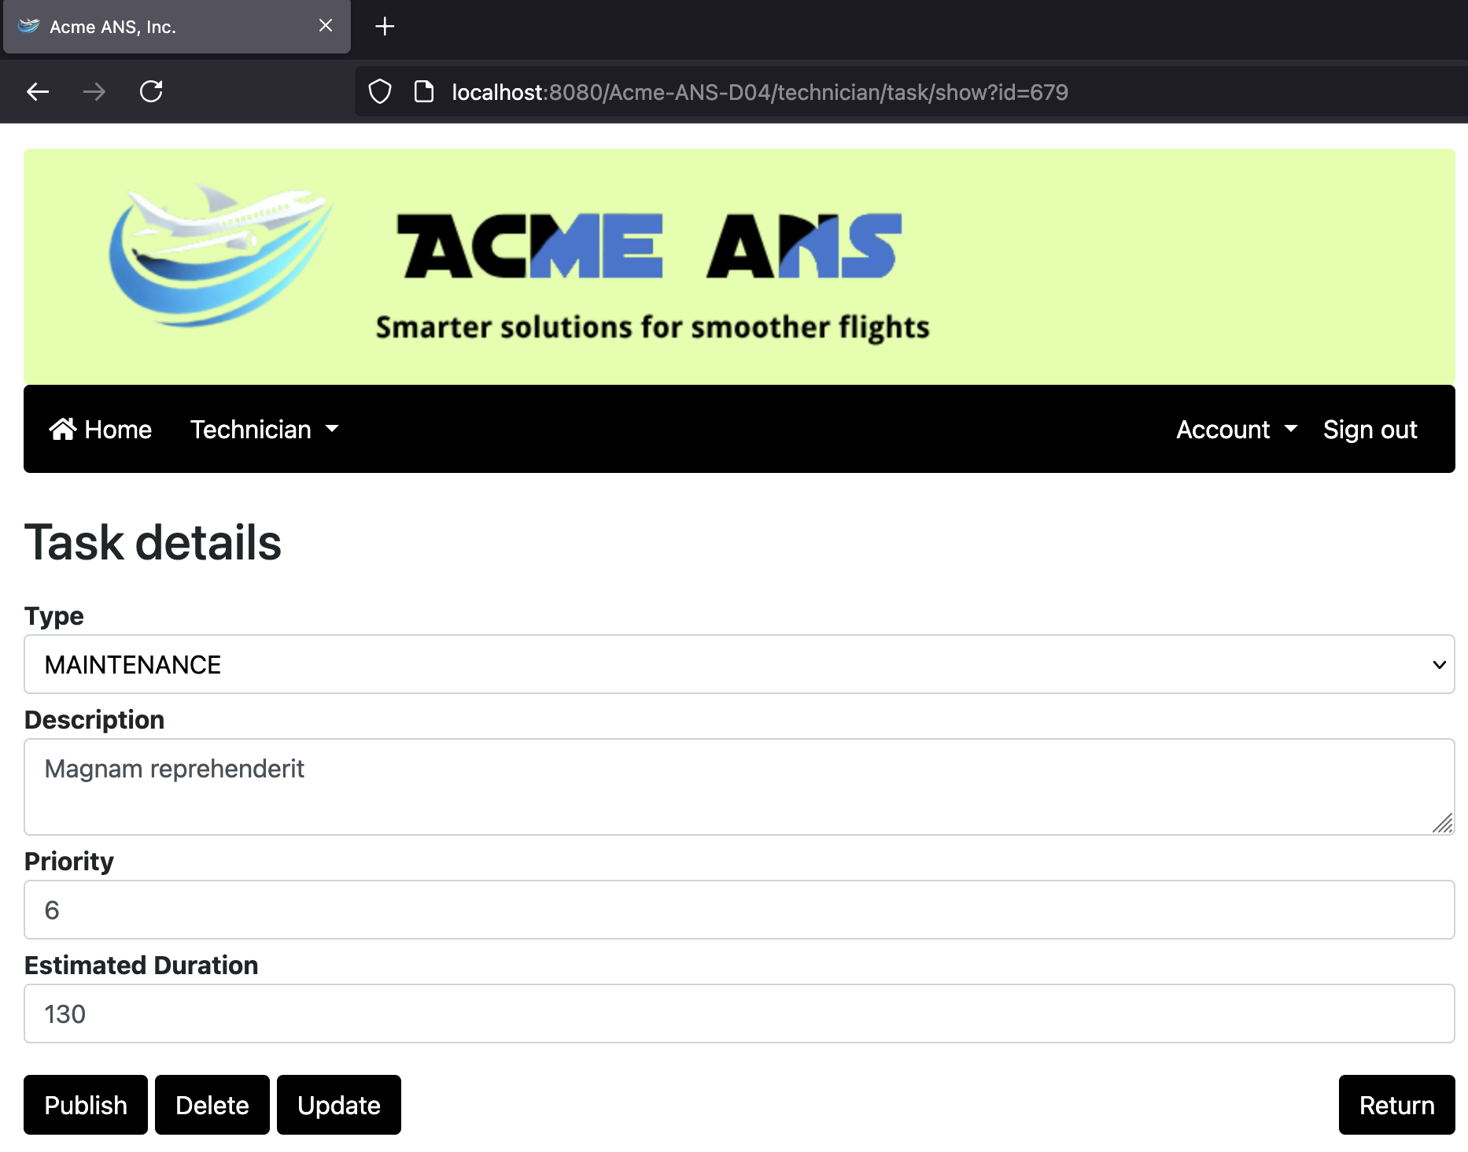

A continuación, entro en el sistema como technician1/technician1 y hago clic en el show de cualquier tarea que no esté publicada y en el formulario de detalle de la tarea, edito el id de la misma con las herramientas de desarrollador de la parte derecha, y escribo id = 679. Finalmente hago clic en publicar:

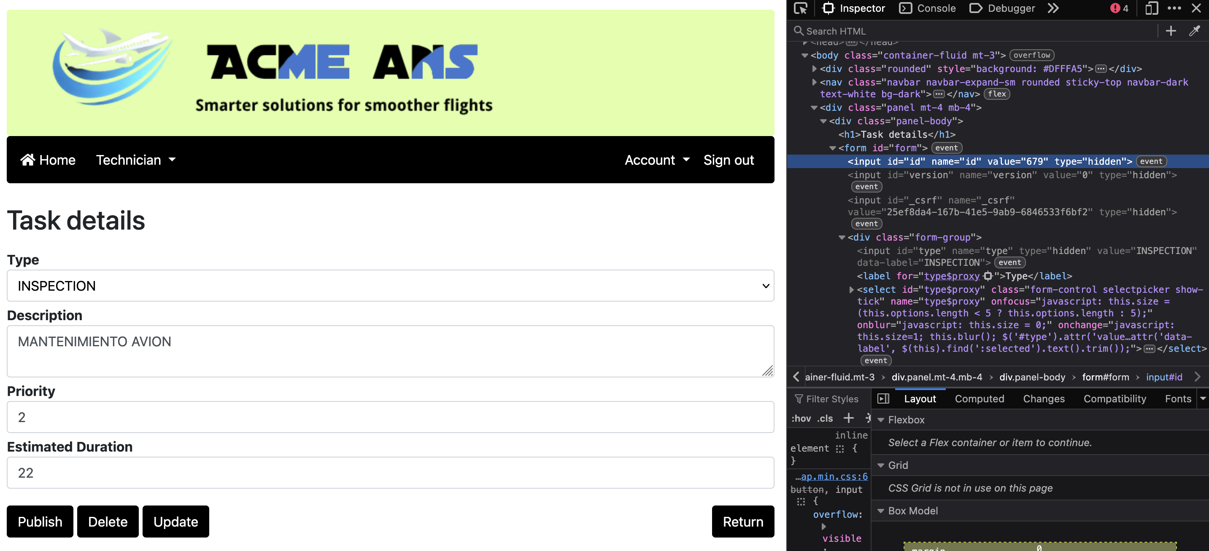

Refresco la vista de detalle de la tarea 679 del technician3 y así es como aparece porque ha sido publicada por el technician1:

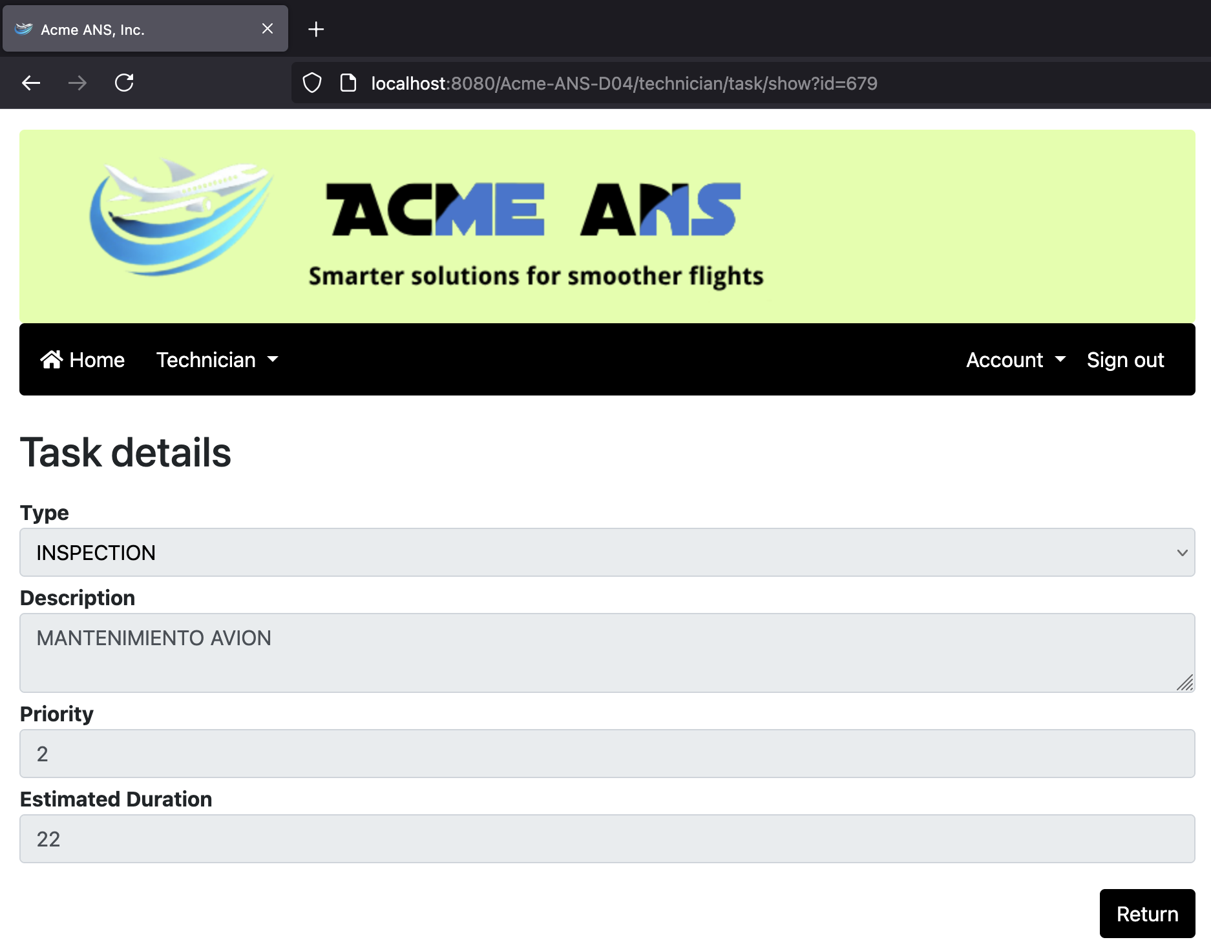

El error fue solventado cambiando el orden de las comprobaciones del método authorise, haciendo que ahora una de las primeras comprobaciones sea la autoría de la tarea y si está publicada o no. El error fue que esta comprobación no era revisada cuando debía serlo, sino que únicamente se revisaba para el método GET, causando que se pudiera realizar un POST hacking.

Y debido a la reutilización del código del método authorise, esto también sucedía a la hora de actualizar las tareas, siendo también solventado este problema.

## Non-functional requirements

Intentionally blank.

## Testing requirements

Intentionally blank.

## Managerial requirements

1. Provide a link to your planning dashboard in GitHub to review the tasks, their current status, and your schedule.

X

# MANDATORY Deliverable D04: formal testing

## Information requirements

1. Create appropriate indices for your entities, if required.

X

## Functional requirements

Intentionally blank.

## Non-functional requirements

Intentionally blank.

## Testing requirements

1. Produce a test suite for Requirements #8 and #9.

X

## Managerial requirements

1. Provide a link to your planning dashboard in GitHub to review the tasks, their current status, and your schedule.

X

1. Produce a testing report.

X

# SUPPLEMENTARY I Deliverable D01: introduction

## Information requirements

Intentionally blank.

## Functional requirements

Intentionally blank.

## Non-functional requirements

Intentionally blank.

## Testing requirements

Intentionally blank.

## Managerial requirements

Intentionally blank.

# SUPPLEMENTARY I Deliverable D02: data models

## Information requirements

1. The system must handle **technician dashboards** with the following **indicators**:

* The number of maintenance records grouped by their status.
* The maintenance record with the nearest inspection due date, provided that he or she is involved in any tasks that need to be performed as part of that maintenance.
* The top five aircrafts with higher number of tasks in their maintenance records.
* The average, minimum, maximum, and standard deviation of the estimated cost of their maintenance records in the last year.
* The average, minimum, maximum, and standard deviation of the estimated duration of the tasks in which he or she is involved.

X

## Functional requirements

Intentionally blank.

## Non-functional requirements

Intentionally blank.

## Testing requirements

Intentionally blank.

## Managerial requirements

1. Produce a UML domain model regarding the information requirements in your project.

X

# SUPPLEMENTARY I Deliverable D03: implementing features

## Information requirements

Intentionally blank.

## Functional requirements

1. Operations by **anonymous principals** on **user accounts**:

* Sign up to the system and become a technician.

X

1. Operations by **technicians** on **user accounts**:

* Update their profiles.

X

1. Operations by **administrators** on **maintenance records**:

* List the maintenance records in the system that are published.
* Show the details of the maintenance records (including the tasks involved).

1. Operations by **technicians** on **dashboards**:

* Show their dashboards.

X

## Non-functional requirements

Intentionally blank.

## Testing requirements

Intentionally blank.

## Managerial requirements

1. Provide a link to a video in which you informally test requirement #8 and #9. Videos should not exceed 10 minutes in length and must be stored at the USE's facilities.

# SUPPLEMENTARY I Deliverable D04: formal testing

## Information requirements

Intentionally blank.

## Functional requirements

Intentionally blank.

## Non-functional requirements

Intentionally blank.

## Testing requirements

1. Perform five mutations in your code and report on the results.

## Managerial requirements

1. Produce a lint report.

# SUPPLEMENTARY II Deliverable D01: introduction

## Information requirements

Intentionally blank.

## Functional requirements

Intentionally blank.

## Non-functional requirements

Intentionally blank.

## Testing requirements

Intentionally blank.

## Managerial requirements

1. Produce an analysis report.

X

1. Produce a planning and progress report.

X

# SUPPLEMENTARY II Deliverable D02: data models

## Information requirements

1. The system is required to have a notice board to advertise **courses** for technicians. A web service must be used to populate this entity with information about courses. Thus, the exact data to store depends on the chosen service, and it is the students' responsibility to define them accordingly. It is also the students’ responsibility to find the appropriate service; no implicit or explicit liabilities shall be covered by the University of Seville or their individual affiliates if the students hire pay-per-use services! The students are strongly advised to ensure that the service they choose is free of charge.

## Functional requirements

Intentionally blank.

## Non-functional requirements

Intentionally blank.

## Testing requirements

Intentionally blank.

## Managerial requirements

1. Produce an analysis report.

1. Produce a planning and progress report.

# SUPPLEMENTARY II Deliverable D03: implementing features

## Information requirements

Intentionally blank.

## Functional requirements

1. Operations by **technicians** on **courses**:

* List the course available and show their details.

1. Operations by **administrators** on **courses**:

* Populate the database with courses data.

## Non-functional requirements

Intentionally blank.

## Testing requirements

Intentionally blank.

## Managerial requirements

1. Produce an analysis report.

1. Produce a planning and progress report.

# SUPPLEMENTARY II Deliverable D04: formal testing

## Information requirements

Intentionally blank.

## Functional requirements

Intentionally blank.

## Non-functional requirements

Intentionally blank.

## Testing requirements

1. Produce as a complete test suite as possible for Requirement #29 ensuring that the web service is properly mocked.

## Managerial requirements

1. Produce an analysis report.

1. Produce a planning and progress report.